Institutional Affiliation

Name

Course Name

Course Code

Date Of Submission

**Net Working.**

**Question 1.**

Attached screenshot of database upload on both YouTube channels in gephi format.

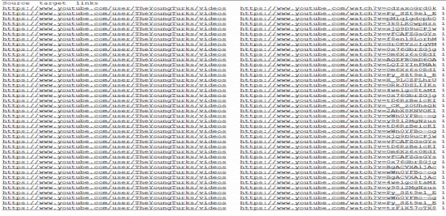

**Question 2.**

On uploading a screenshot of “Overview" tab in Gephi, which shows your network after running the Layout algorithm.

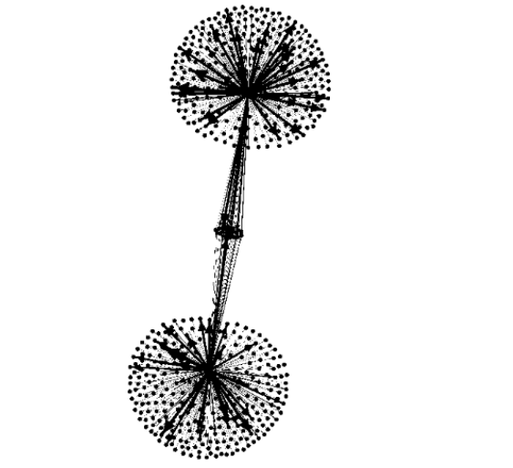  
  
  
**Question 3.**

Calculating the average Degree of your network, the Display and analysis of all three resulting network measures:  
1. Degree.

Average degree = 1.038

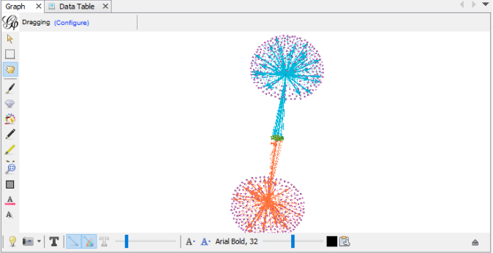

**Degree distribution.**

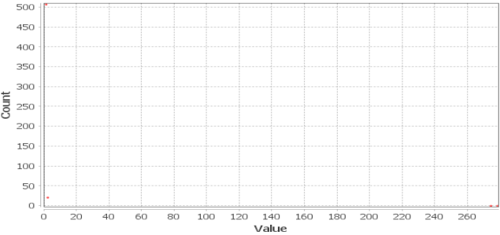

2**. In-Degree**

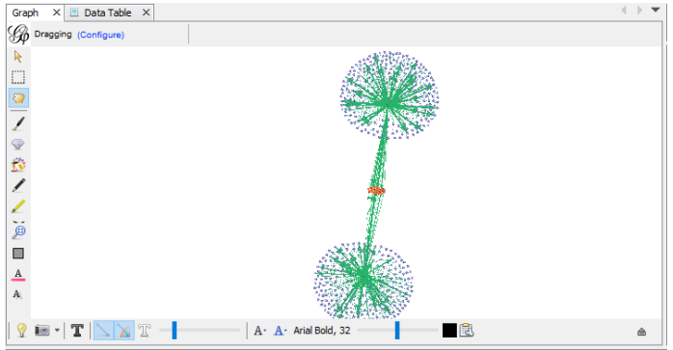

**In-Degree Distribution.**

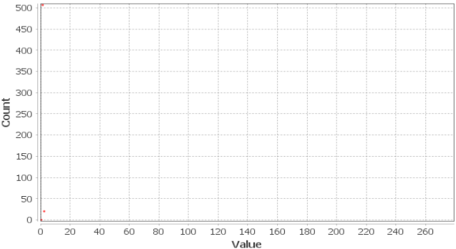

**3. Out-Degree**

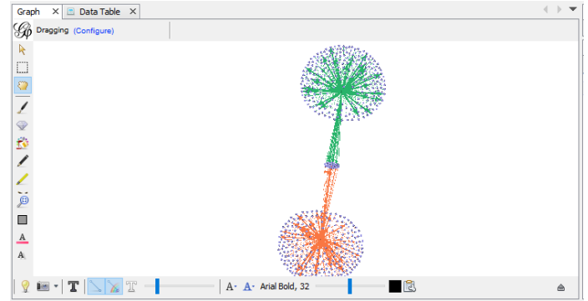

**Out-degree distribution.**

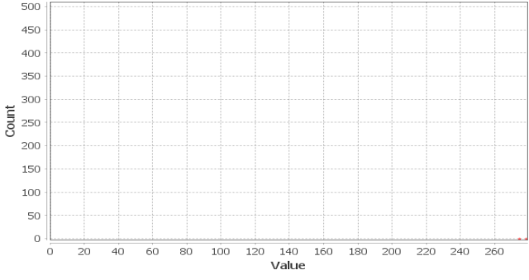

**What is the difference between them?**

By analyzing the interaction between 2 separate YouTube users, we will be identifying the relation. Other than that the difference between the degrees will emerge.

The term ‘degree’ refers to the total node degree and illustrates both information details.

The term ‘in degree’ is used to denote incoming node connections of the nodes which the user interacts with, in this particular scenario represented by the video nodes. Moreover, showcased categories illustrate videos and user information.

‘Out degree’ describes incoming node connections from opposing or alternate nodes which in this case depict that the users interaction on a ‘without degree basis’ are YouTube users. Specifically shown here are two users and videos from the catalogue.  
  
**How many categories do you get for each?**

|  |  |  |
| --- | --- | --- |
| S.no | Degree Type | Count |
| 1. | Degree | 5 x categories |
| 2. | In-Degree | 3 x |
| 3. | Out-Degree | 3 x categories |

Q. **Can you make sense of the numbers that indicate the number of degree per category for each of the three measures?**

From my perspective it is prudent to state that the degree count per category is quite sensible.bo the information sets are shown here with the degree being denoted as the overall node degree. In degree will portray incoming connections emitted from the notes to other nodes. Out degree will show incoming node connection emanated from other nodes.

**Question 4**. How many nodes (videos) are shared by both YouTube channels?

The total shared node count existing between the sub networks meaning (videos to users ) is 22.the videos with the degree rating of 2 help identify this.   
**Count them or calculate them**.

22 videos is the shared node count.

**Question 5.** Calculate the "Undirected Closeness Centrality" for your network, through "Average Path Length":

Average path length=**2.914**

**Closeness Centrality Distribution.**

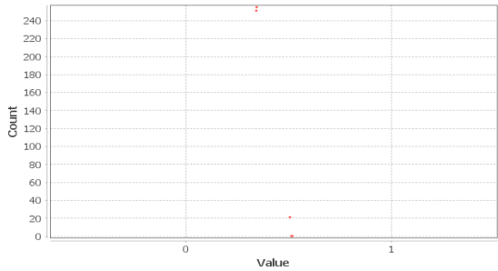

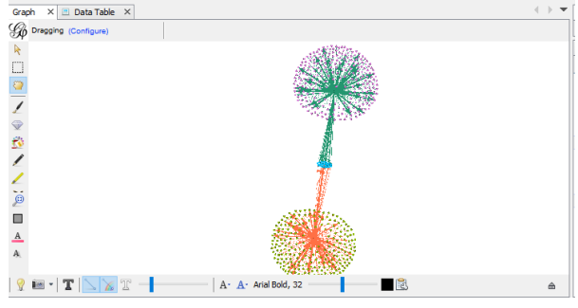

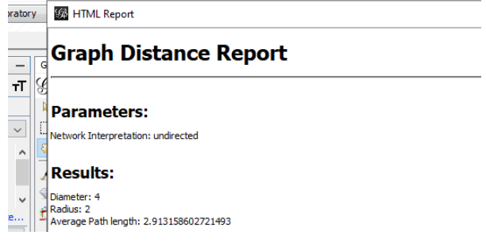

**How many groups of nodes do you get?**

By use of the undirected closeness centrality method, we proceed to partition the network and the derivative value is 5GROUPS of nodes. Users /sub network nodes are identified by 2 x colors. These colors are closest to the sub network nodes for example the color dark green and color orange. Sub network nodes are identified by 2 x colors when connected to the main node in 5x colors. These colors within the 2x realm are purple and light green .1 x color distinguishes between regular nodes and main nodes/sub networks, blue here is the color for selection.

**Please upload a screenshot of your network (taken on Mac or Windows: "Insert > Image") and interpret the different groups in a paragraph:**

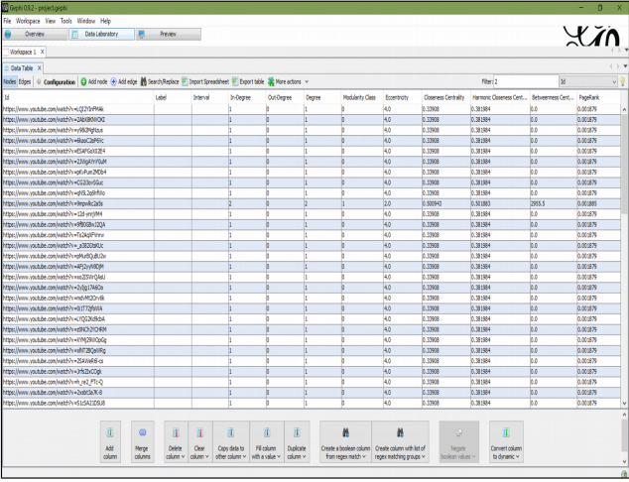.

**Which nodes are part of which group and why?**

Main users /nodes are grouped into one category while common videos nodes grouped into another.2x grouped project non common nodes/videos to esteemed users.

**Question 6. Calculate PageRank for your network, a special version of Eigenvector Centrality**.  
Attached below is a screenshot of the distribution network.

**PageRank distribution**

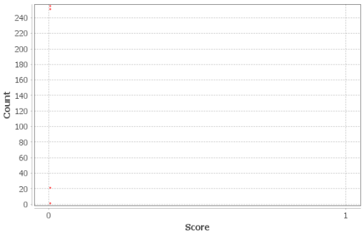

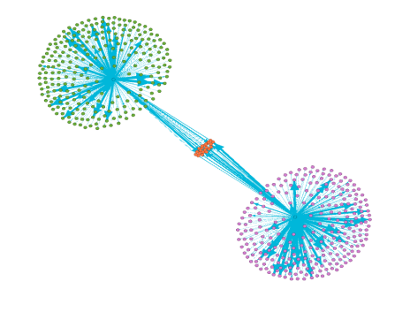  
**How many groups of nodes do you get for PageRank? What do they measure? Is this useful**?

From page rank we derive 4 x groups on the graph. Yes ,It is useful since the sub graph identification provides a look into the elements connected to the main nodes, giving extended ideas on sub graph detailing.  
**Question 7. Please upload a screenshot of your "Data Laboratory" tab, now at the end, after you have done the preceding analysis.**Go to "Data Table > Nodes" (not Edges) and make sure that the "Id" column is completely readable (not cut off to its right):

